

**“Emergency response techniques by measuring heart rate and blood pressure via smartphone application”**

**By**

**Vimal Jaswal**

**B00122875**

Master of Engineering in Internet of Things Technologies.

Supervised by Dr. Brian Debrit

School of Informatics & Engineering, Department of Engineering

TU Dublin – Blanchardstown Campus

Blanchardstown, Dublin 15

June2020

# CONTENTS

1. Executive Summary

2. Introduction

3. Project Evolution

3.1. Original Project Objectives

3.2. Evolution of Project Ideas

3.2.1. Different Ideas Considered

3.2.2. Final Project Objectives

3.3. Project Challenges

3.3.1. Covid-19

4. Literature Review

4.1. Use of IoT in Health Monitoring

4.2. Overview of Similar Projects

4.2.1. “MEASURING VITAL SIGNS USING SMART PHONES”

4.2.2. “Assessing blood-pressure measurement in tablet-based mHealth apps”

4.2.3. “oHealth: A self-care android application for senior citizens with hypertension”

4.2.4 “HeartBeat+: A Development of Mobile Application on Recording and Monitoring Blood Pressure Readings for Hypertensive Patients”

4.3. Overview of Component Technologies

4.3.1. Smartphones and Smartphone Sensors

4.3.2. Cloud Computing

4.3.2.1. Databases

4.3.3. Mobile App Development

4.3.3.1. Discuss mobile app development without referencing specific platforms

5. Technology Review

5.1. Android vs iOS

5.2. Cloud Computing

5.2.1. Amazon AWS

5.2.2. Google Cloud

5.2.3. IBM Cloud

5.2.4. Microsoft Azure

5.2.5. What is most suitable and why?

5.3. Mobile App Development

6. Project Plan and Future Work

6.1. Detailed Project Plan

6.1.1. Gantt Chart

# Executive Summary

The Scenario of operating devices and communication of devices has been changed with the advancement in internet of things. This led every sector to change the fundamental techniques and operations. Today we see that mobile devices can communicate to each other via internet and cloud platform. Machines of mobile size can operate other machines without much effort that require so much effort in earlier days. Today Smartphones and other computing devices can be used as Information, Communication and Operation technology devices that can do all of processes of our manual work by giving pre-programmed instructions to other machines.

Every sector has been implementing the IoT technology for fast, easy and profitable access in their business. This has provided improved efficiency and result in various sectors such as Smart health, Smart houses, Smart Car Parking, Chemical industry, Transport, Medical etc. The Implementation is yet not up to the full potential. But sensor-based operations and communication has improved the way of living standard and public services efficiently than it was a couple of years ago.

This report sheds light on need of healthcare application for resolving issues caused due to any kind of uncertainty. The report follows with the introduction of the problems and questions that arises due to that problem. Secondly, it describes the way to answer the solution of problem and its requirement. Thirdly the report shows analysis of literature and technological review for the development of paradigm and application and plan for the succession of the work.

# 2. INTRODUCTION

The Internet of things is the technology that brought valuable change in most of the fields. Healthcare sector is also benefited from the internet of things. The productivity in quality of care to patients in the healthcare sector has been improved in the past few years. Due to rise in health problems, new viral diseases and recent COVID-19 pandemic, it has been clear that there is an essential requirement of remote healthcare systems or applications. Today there are many mobile applications available to communicate between doctor and patients. These applications provide doctors with essential changes in a patient's normal activity so that the doctor can provide appropriate treatment.

In this research the main focus is to develop a paradigm that can help patients the necessary treatment based on the data collected by Smartphone. The experiment is to collect data from a patient via Smartphone and send it on to cloud service and then transform that into information required by a carer or doctor.

The main aim of this research is to develop an android application for the healthcare sector that uses the internet of things and cloud service technology. The Smartphone’s inbuilt features will be used to collect data from patients and will be stored in a cloud database which can be retrieved and processed for further analysis by individual, family, doctor or health care. The idea presented could help improve the use of Smartphone’s for improvement in many healthcare sectors.

# 3. Project Evolution

**Problem statement**

There are many types of fitness applications and patient monitoring applications or devices available in market that can provide users with the information related to their physical condition. Even if patient activity is monitored there is a mandatory requirement of the doctor to assist the patient with diet and prescription in case of a disease. There is still a requirement of such applications that can help improve the emergency support in case of need by the patients. Another issue is that there is less number of doctors available as compared to patients. The situation became worse in case of natural disaster or pandemic.

The unavailability of medical service or support when required could result in panic or mental stress to the patient which further increases the problem. Moreover, for the elderly people who do not have anyone to look after the problem is worse.

## 3.1 Original Project Objectives

The main objective is to look at various scenarios that can be helpful in resolving the problem of monitoring patients from remote location. Secondly, to look at the current scenarios already present and how these can be improved further in case of different emergency situations.

**Aim of the research**

The main aim of the research is to help people in the society to prevent from emergency medical conditions and provide best possible response from doctors and medical services.

The research will help healthy people, people with medical conditions, elderly people, people with very busy daily routines, people living away from urban areas, people working in medical services such as doctors and health carers.

***Research Question***

The research question is developed from research aim, objective, practical medical services problems.

This research will shed light on providing a quick and appropriate solution for the research question.

***"How can we improve emergency medical services by determining medical parameters like blood pressure and pulse rate via Smartphone application?"***

## 3.2 Evolution of Project Ideas

### 3.2.1. Different Ideas Considered

* Researching and developing an algorithm for patient heart rate and blood pressure measurement and writing a program to better understand the functionality of the project.
* Analysing use case and features that can be employed in the development of measurement of heart rate and blood pressure measurement in case of Smartphone application.
* Researching on required electronic component and software services that can be used for feasibility of mobile application

### 3.2.2. Final Project Objectives

The Final objective of this research is to develop a user friendly and efficient Smartphone application to monitor patients without the need of frequently visiting doctors or hospitals and without use of extra medical devices.

The individuals will receive an answer about how will the mobile application developed via this research will help to reduce response time of medical professionals and emergency services along with helping individuals to control and warn them about their medical condition which will motivate individuals to live a healthy life and take preventive measures which in turn will decrease the risk from disease caused due to tension of unavailability of medical service and save lives.

## 3.3. Project Challenges

### 3.3.1. Covid-19

Closing of university and campuses to slow down the spread of Corona virus has hampered the learning and research majorly. It is a challenge to decide on type of sensors, software and hardware technology components that can be employed for research project. It is also a challenge to tackle with the stress and other daily life activities issues while staying indoors and following social distances and preventive measures to stay healthy for working on the research.

# 4. Literature Review

## 4.1. Use of IoT in Health Monitoring

**“Health Monitoring and Management Using Internet-of-Things (IoT) Sensing with Cloud-based Processing: Opportunities and Challenges”**

Hassanalieragh et al. (2015) conducted research on personalisation of health treatment and management options to reduce the cost of health care management. In view of current innovative techniques, one can promptly envision a period sooner rather than later when your routine physical assessment is gone before by a multi day time of consistent physiological checking utilizing economical wearable sensors. Over this stretch, the sensors would constantly record signals related to your key physiological boundaries and transfer the subsequent information to a database connected with your wellbeing records. At the point when you appear for your physical assessment, the specialist has accessible not just ordinary facility/lab-test based static estimations of your physiological and metabolic state, yet additionally the a lot more extravagant longitudinal record given by the sensors. Utilizing the accessible information, and helped by choice emotionally supportive networks that additionally approach a huge corpus of perception information for others, the specialist can improve a much visualization for your wellbeing and suggest treatment, early intercession, and way of life decisions that are especially powerful in improving the nature of your wellbeing. Such a problematic innovation could transformatively affect worldwide medicinal services frameworks and definitely diminish social insurance costs and improve speed and precision for analysis. They checked on the current state and anticipated future bearings for a combination of remote wellbeing observing advances into the clinical act of medication. Wearable sensors, mostly provided with IoT knowledge, offer appealing choices for empowering perception and recording of data in home and workplaces, over any more lengths than are as of now done at office and research center visits. [1]

**“Smartphone Applications for Patients' Health and Fitness”**

The article presents abilities of the Smartphone sensors and potential applications for individual wellbeing checking and health of executives. It compared the design and association of wellbeing applications, observing frameworks, Body Sensor Networks, and coordination of wearable and ecological sensors. It also looked at various versatile wellbeing related applications in the present portable commercial centers, for example, Google Android and Apple App Store Marketplace. It presented the improvement of health applications and wellbeing observing framework for health, intended to screen physical action, weight, and heart action, Continuous checking and constant, altered input on wellbeing and conduct will progressively depend on remote and organized sensors and actuators, versatile stages, novel intuitive shows, and improvements in registering systems. [2]

**“Ireland smartphone users/ internet access /mobile phone / health application”**

According to the prediction done on Ireland mobile users by S. O'Dea from the Statistical Research department suggests that by 2022 smartphone users in Ireland will probably cross 4.06 million. Another analysis report suggests that the number of smartphone users in the globe will cross the five billion. According to these reports and forecasts it is suggested that the number of smartphone users in the world will be growing explicitly. The report also evident that Android operating systems smartphones is eighty percent and other operating systems such as iOS and windows is twenty percent of the total market of smartphones.Moreover, with the hike in smartphone users will also increase internet usage. As per (NW et al., 2016) the internet access is comparatively higher in case of United States and Europe with eighty percent internet access rate. Furthermore, usage rate for the internet in developing nations is also booming with the hike in usage of smartphones. Today, Smartphones are available at affordable prices. (Holst, 2019)

There are many features and specifications in a smartphone which have got improved via access of the internet. One of such features available is global positioning system to track the location of a mobile device. This feature is very crucial for people in trouble. Smartphones have many other properties such as text messaging, microphone and camera for face detection, video and audio recording, fingerprint sensor for several individual security means such as unlocking the phone or applications with sensitive data. People use smart phones for various tasks or daily functions. The activities on smart phones are different among people and rely on individuals as per their requirement. It also relies on the individual's liking, hobbies, age and interests. As per the report on Ireland smart phone users from the Statistical Research department the consumers of smart phones increased among older age group.[3]

## 4.2. Overview of Similar Projects

### 4.2.1. “MEASURING VITAL SIGNS USING SMART PHONES”

Chandrasekaran (2010) investigated on the feasibility of measuring vital parameters of human body via smartphone and some additional devices that can be added. The research also includes the applicability and comparison with traditional measurements. Accordingly, Body temperature, heart rate, respiration rate and blood pressure are important indicators also known as vital signs in the case of the human body. These indicators assist in monitoring the physical wellness of human beings. The person's condition is treated as abnormal when the normal range of these vital parameters shifts away. These parameters help in diagnosing many medical conditions of a person. These vital parameters are measured using various medical devices or special equipment. Heart Rate or Pulse rate is the number of times a human heart beats in one minute and is particularly an indication of heart conditions. Heart rate depends upon various factors but its normal range is 60-90 beats per minute (bpm) in adults. Heart rate is used to find various symptoms related to conditions such as palpitations (rapid heartbeat), faintness, dizziness, heartburn, shortness in breathing or chest pain. Heart rate determines diseases like bradycardia(where heart rate is below normal value) and tachycardia(where heart rate is above normal value). Cardiac arrest can be caused due to high heart rate issues. It is very important to measure heart rate during or after physical exercise as a person’s cardiovascular fitness and wellness can be determined. [4]

### 4.2.2. “Assessing blood-pressure measurement in tablet-based mHealth apps”

Murthy and Kotz (2014) investigated on the use of tablet for the arm movement for different posture and its feasibility for accurate measurement of blood pressure measurement application. According to WHO (World Health Organization), CVDs (Cardiovascular diseases) is the major cause of death. ("Cardiovascular diseases (CVDs)," 2018) The generic term for heart-related diseases is CVD (Cardiovascular disease). Diseases such as Aortic disease, Coronary heart disease, Strokes and Peripheral arterial disease are of its main kind. They happen due to several factors that alter the normal functioning of the heart.In the globe today, smartphone and World Wide Web becomes a mandatory spot for the individuals. Smart phones have entered into a need for everyone. Currently, for health monitoring via smart phones can be employed as health services. The most common and widely recognized diseases are heart rate and blood pressure.

### 4.2.3. “oHealth: A self-care android application for senior citizens with hypertension”

Ghoshachandra et al developed an android mobile application to personally measure and monitor their vitals by the application user. The research conducted was targeted on elderly people going through hypertension referred to as high blood pressure issues. The specific property of the application is to record the blood pressure using external devices. It also included properties such as medicine log, diet log that the patient can use during treatment. The data was stored in Azure’s SQL database. Azure Machine Learning being employed by the researchers to analyse the information. Multiclass Logistic Regression is used algorithm to analyse data from the user. Machine learning algorithm based system of Azure is used. The data of the patient is collected as history data which could be distributed among patients, carers, doctors, etc. The limitation of this application is the need of external devices to measure the blood pressure. [7]

### 4.2.4 “HeartBeat+: A Development of Mobile Application on Recording and Monitoring Blood Pressure Readings for Hypertensive Patients”

Cruz et al. (2018) developed a mobile and web application for patients to analyse and record their blood pressure. In the application the researchers includes the reminder functionally for patients to set an alert for them to take their medicine. The patients could also make log of diet plan as diet is also related to high blood pressure. The web application also shows the users recorded history. This record is for viewing later by the doctors to keep a check on patient's activity and diet which assist them to change the medication as per the requirement. [8]

## 4.3. Overview of Component Technologies

### 4.3.1. Smartphones and Smartphone Sensors

Smartphones are used for various purposes today and have various features to connect with other web technologies, other mobile operating systems and cross platforms to transfer various types of information. Smartphones today contain a number of features such as camera, bluetooth, finger print, global positioning system for location, microphone, accelerometer, wireless fidelity, mobile data etc.

There are many Operating Systems for smartphones. The main mobile operating systems (OS) used by modern smartphones includes the following:  Google's Android, Nokia’s Symbian, Apple’s iOS, RIM’s BlackBerry OS, Microsoft's Windows Phone. Such operating systems can be installed on many different phone models, and typically each device can receive multiple OS software updates over its lifetime. Android from Google and IOS from Apple provide not only operating systems but also provide a mobile development platform because both of them are facing tough competition against each other. Now we are going to talk about the main operating systems respectively android and IOS which are commonly seen in the market. [5]

### 4.3.2. Cloud Computing

Cloud computing is the online accessible availability of computing resources without any need of continuous management by the users. The term is mostly used for data centers, mobile servers and cloud data storage. There are various service and deployment models of cloud services.

#### 4.3.2.1. Databases

Database is term used for computing storage where data related to stored information is kept in form of particular format or record. Structured query language is used for reading and writing data in database. Some databases does not use structured query language and widely used for storing real time data nowadays. A cloud database is used in terms of cloud computing platform where databases are used as a service.

### 4.3.3. Mobile App Development

The process of developing an application interface or mobile app for Smartphone that can be pre-installed or installed later as per mobile user is termed as mobile app development. Mobile app development has become more crucial for many industries and Business. There are around 3 billion Smartphone users in the world and 1.5 billion using tablets. Smartphone users invest 90 percent of their time in using mobile applications.

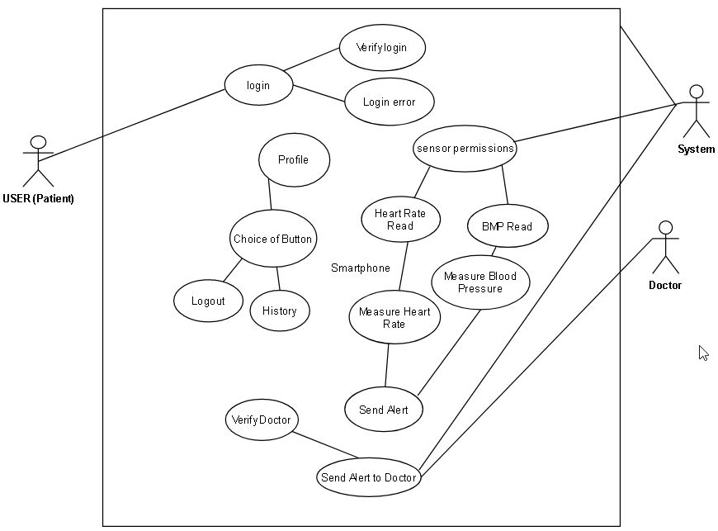

Figure 1: UML diagram for development of application program

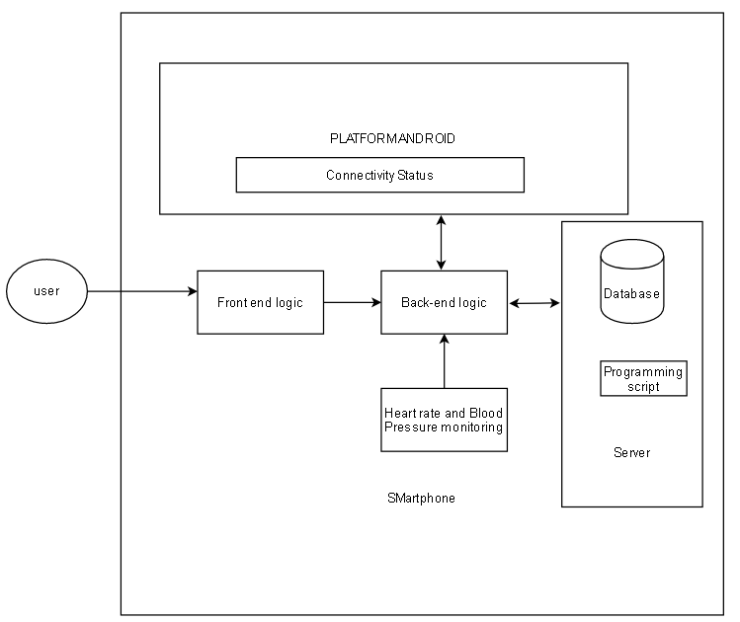

Figure 2: Architecture for development of application program

# 5. Technology Review

# 5.1. Android vs iOS

Android and iOS are the topmost mobile operating systems for smartphones all over the world.The android marketplace is rapidly increasing as compared to the iOS. Android platform has a challenging growth in terms of development as it is acquired by google and many of its open source features. There are different perspective to observe the comparison between these two operating system platforms but both are having own unique features.[5]

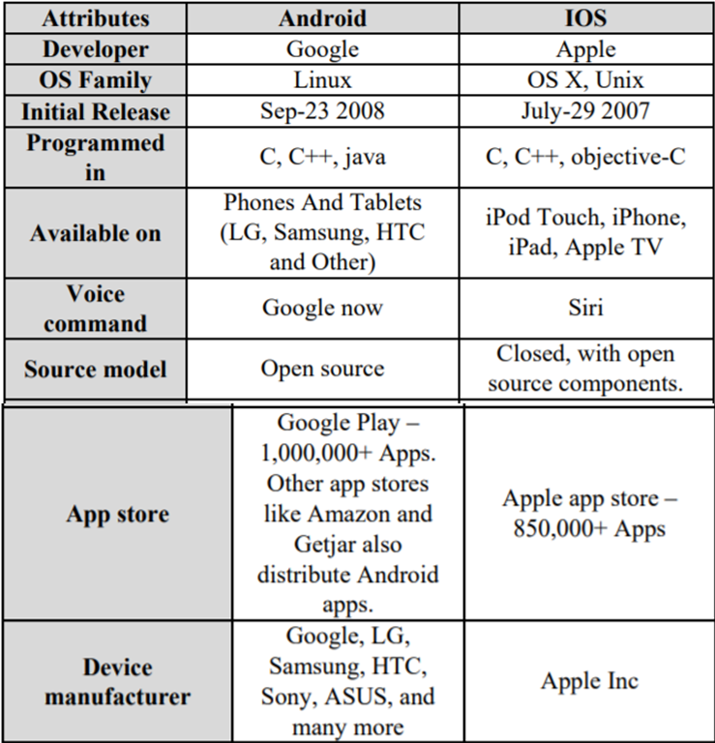

Figure 3: Comparison of Android and IOS (Sheikh et al. 2013)

## 5.2. Cloud computing services

### 5.2.1. Amazon AWS

Amazon provides database services as well as other cloud services and is a leading competitor in cloud storage service offerings. Amazon's general-purpose relational DBMS, Aurora, has a storage capability from 10 GB to 64 TB. Amazon uses machine learning to getinsights and automates warehouse management tasks via petabyte-scale data warehouse platform and Redshift. Apart from that it also offers No SQL, MongoDB supportable database known as Document DB, DynamoDB for document, Neptune that represent graphical applications, Timestream for statistical data storage, ElastiCache for deployment. The database as a service platforms provided by Amazon include Oracle, MariaDB, MySQL, SQL Server, and PostgreSQL.[9]

### 5.2.2. Google Cloud

Google also offers worldwide services of electronic cloud database as a service. Cloud SQL and Cloud Spanner are popular which are compatible with PostgreSQL, SQL Server and MySQL. NoSQL products of google involves Cloud Firestore related to document storage, Firebase that uses JSON which is a Realtime Database for real-time data synchronization and Bigtable for high level workloads.

### 5.2.3. IBM Cloud

IBM also provides various virtualisation and cloud storage services for connecting different computing machines and hardware. IBM Watson is one of the platforms for internet of things application services. IBM Greenhat and Smart cloud are some of popular service names.

### 5.2.4. Microsoft Azure

Microsoft has many services for big data applications and its relational database product involves Azure SQL database. Azure has enhanced its 4TB limit on its Azure SQL database. The NoSQL database services provided by Microsoft are Azure table storage, Cosmos database and Azure cache. Microsoft also provides open source products such as MariaDB, PostgreSQL and MySQL.

### 5.2.5. What is most suitable and why?

Google cloud services are good for managing application data as it has a variety of cross platform and open source resources that could be efficient in terms of implementation. Microsoft azure is also suitable for the virtualisation of the functionality of the project.

**5.3. Mobile App Development Tools**

There are various app development tools available. Sencha is a tool to develop apps in HTML5 that can be translated to both iOS and Anroid. Phonegap and flutter are another tools that can be used to develop applications for different smartphone system platforms. Android studio is an integrated development environment tool commonly used for development of mobile applications with a variety of cross platform plugins.

**6. Project Plan and Future Work**

**6.1. Detailed Project Plan**

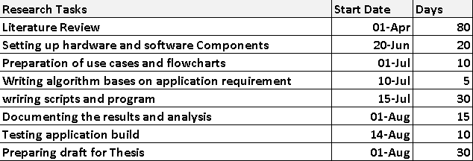

**6.1.1. Gantt Chart**

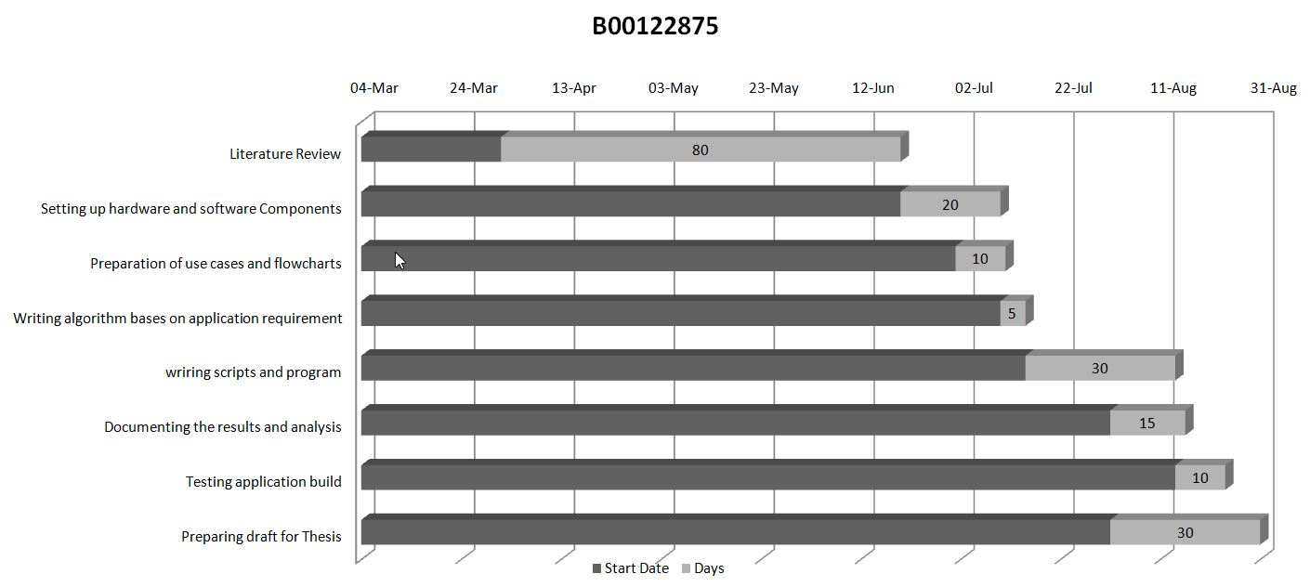

# References

[1] Hassanalieragh, M., Page, A., Soyata, T., Sharma, G., Aktas, M., Mateos, G., Kantarci, B. and Andreescu, S., 2015, June. Health monitoring and management using Internet-of-Things (IoT) sensing with cloud-based processing: Opportunities and challenges. In *2015 IEEE International Conference on Services Computing* (pp. 285-292). IEEE.

[2] Higgins, J.P., 2016. Smartphone applications for patients' health and fitness. *The American journal of medicine*, *129*(1), pp.11-19.

[3] Number of smartphone users worldwide | Statista [online] Available at: https://www.statista.com/statistics/263453/global-market-share-held-by-smartphone- operating-systems/ (accessed 10.04.20).

[4] Chandrasekaran, V., 2010. *Measuring vital signs using smart phones*. University of North Texas.

[5] Murthy, R. and Kotz, D., 2014, January. Assessing blood-pressure measurement in tablet-based mHealth apps. In *2014 Sixth International Conference on Communication Systems and Networks (COMSNETS)* (pp. 1-5). IEEE.

[5] Sheikh, A.A., Ganai, P.T., Malik, N.A. and Dar, K.A., 2013. Smartphone: Android Vs IOS. *The SIJ Transactions on Computer Science Engineering & its Applications (CSEA)*, *1*(4), pp.141-148.

[6] Pixelfield. 2020. *The Ultimate Guide To Mobile App Development - Tips, Prices & More!*. [online] Available at: <https://pixelfield.co.uk/app-development/> [Accessed 17 May 2020].

[7] Ghoshachandra, P., Limkriengkrai, C., Wimonsakcharoen, P. and Tangsripairoj, S., 2017, May. oHealth: A self-care android application for senior citizens with hypertension. In *2017 6th ICT International Student Project Conference (ICT-ISPC)* (pp. 1-5). IEEE.

[8] Cruz, B.D.D., Encina, A.R.H., Macale, H.M., Lavarias, C.N.R., Ramirez, E.Q., Jamis, M.N., Bermudez, J.R.D., Guadaña, R.R.H. and Yabut, E.R., 2018, November. HeartBeat+: A development of mobile application on recording and monitoring blood pressure readings for hypertensive patients. In *2018 IEEE 10th International Conference on Humanoid, Nanotechnology, Information Technology, Communication and Control, Environment and Management (HNICEM)* (pp. 1-5). IEEE.

[9] SearchDataManagement. 2020. *Cloud Database Comparison: AWS, Microsoft, Google And Oracle*. [online] Available at: <https://searchdatamanagement.techtarget.com/tip/Cloud-database-comparison-AWS-Microsoft-Google-and-Oracle> [Accessed 17 June 2020].